**Angels and the Resurrection Story in the Gospels**

**Daniel Dietsche**

**CSCI/REL 195**

**4/20/2016**

My first idea for a project was to compare some story or parable from each of the four gospels. I was interested in seeing how each of the books differed in how they told the story. I looked up a list of stories that were in all four gospels online, and the story that I decided to look at was the resurrection of Jesus after his crucifixion. Before writing a program to help me, I decided to read through each of the stories to see what I wanted to focus on. While looking at the four different texts, I noticed something interesting. Each of the stories have mention of an angel, waiting at the tomb to tell the women that Jesus has written, except for the narrative in Mark. Mark, instead, mentions a young man in a white robe. I decided to put my initial examination of the difference between the presentations of the resurrection story in each gospel on hold, instead examining each of the gospels for mentions of angels. I wrote up a program in python to help me with this examination.

My program, angel_check, uses the NLTK toolkit to find each use of a specific word in its context using the concordance function, in this case angel and angels. It also gives a dispersion plot of both of the words. I ran each of the gospels through this program, and examined the output of the program, shown in the [name_of_gospel]Angel text files. The results of this are shown in the following *graphs*:

Figure 1: Bar chart showing frequency of angel and angels by gospel book.

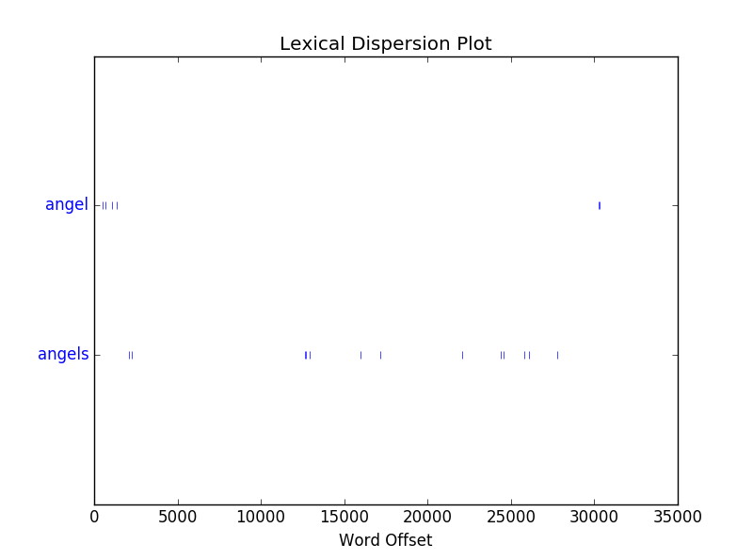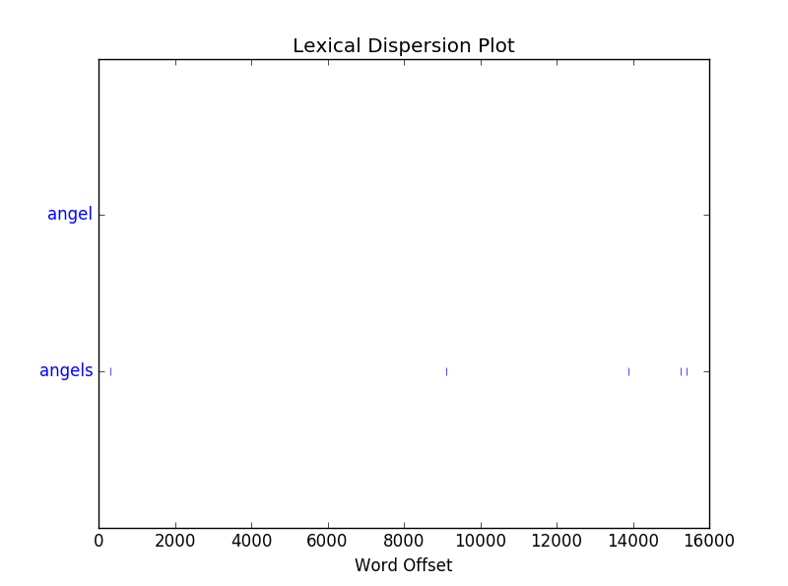

Figure 2: Dispersion Plot for Matthew of angel and angels.

Figure 3: Dispersion Plot for Mark of angel and angels.

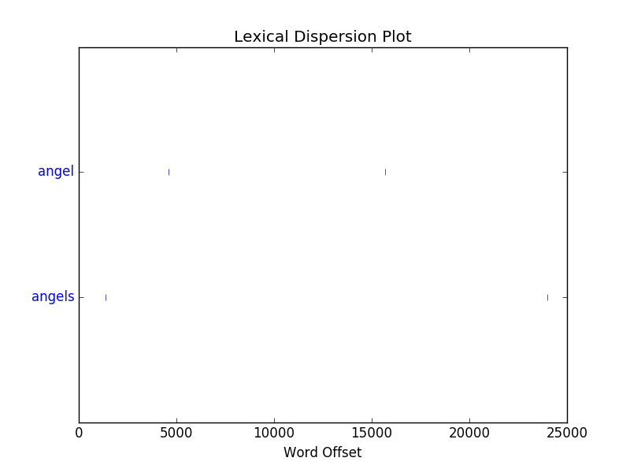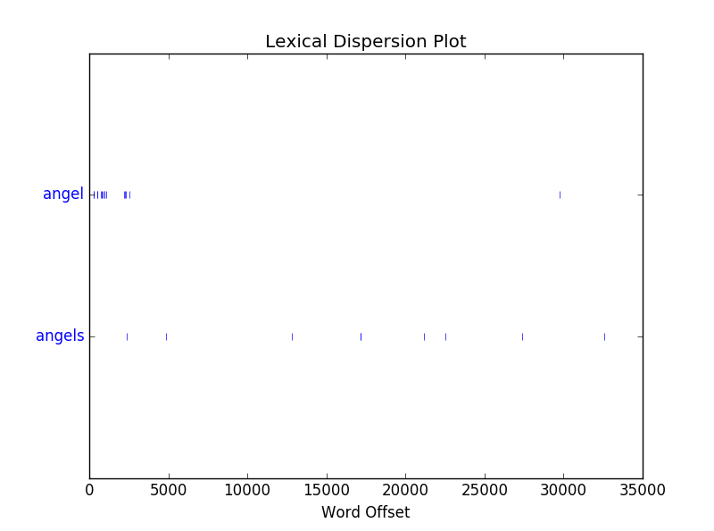

Figure 4: Dispersion Plot for John of angel and angels.

Figure 5: Dispersion Plot for Luke of angel and angels.

It was while looking at the results that I noticed something interesting about Matthew’s usage of angels. Matthew has a decent amount of talking about the end of days and various apocalyptic stuff. A lot of the places where angels appear is in these apocalyptic parts. For example, there are passages like “The harvest is the end of the age, and the reapers are angels” (13:39) and “The angels will come forth and separate the wicked from among the righteous” (13:49). This association between angels and end-of-days ideas is shown in the resurrection story, as it tells of an angel who comes down to roll away the stone in front of the tomb. When the angel arrives, there is a great earthquake, and the guards at the tomb are terrified. This earthquake is symbolic of the apocalyptic background that Matthew gave the angels in his book.

Mark, unlike Matthew, doesn’t talk that much about angels. But when he does, they still show up in apocalyptic ideas. Four of the five uses of the word ‘angels’ are in reference to the end days, or at least to when Jesus will return to being with his father. The one use of angel not in reference to that is in the brief touch upon the 40 days Jesus spent in the wilderness, where Mark says the “angels were serving him.”

Luke uses angels the most out of the four gospels. There was a lot of mentions of angels in the birth narrative from Luke. Luke also has no real reference to the apocalyptic ideas that both Matthew and Mark share, at least in reference to angels. John references angels the least out of the four, and like Luke, none of the references are for apocalyptic ideas.

So now that we have this, we can return to the analysis of the resurrection stories, and what changed for each of the narratives. Each of the changes can be attributed to the point of the gospel, to the audience and intent behind it. It is generally accepted that Mark is the earliest gospel, and he focuses on getting the story out. Matthew is considered next, and his intended audience is the Jews. Third is Luke, who writes to the Greeks. Finally, there is John, who writes more to a Christian audience.

Mark is generally considered the earliest of the gospels. In his account of the resurrection (Mark 16:1-11), he details the initial story: women coming to the tomb, learning that Jesus has disappeared, and reporting this to the disciples. Even though Mark does not explicitly use the word angel, his ‘young man’ is most likely an angel.

Matthew adds a bit more in his telling (Matthew 28:1-10), due to his focus on writing to a Jewish audience. The addition of guards at the tomb is to contradict the idea that the disciples removed Jesus’ body. He made it so that the person who met the women at the tomb was definitely an angel, and the earthquake was, as stated above, another tie-in to the angel-apocalyptic connotations. Matthew also included an appearance by Jesus, who showed himself to the women as they left the tomb. This could be to reinforce that the disciples did not move the body, because if he was seen before the disciples came to the tomb, they couldn’t have moved the body.

Luke, who wrote a Greek audience, does not mention guards in his telling (Luke 24:1-12) because there is no suspicion from the Greek audience that the disciples moved the body. He also has not one, but two angels who meet the women at the tomb. These angels are described as two men in dazzling clothing, and like Mark, are not specifically called angels, but they are almost definitely, what with the description of their clothes as dazzling. Jesus also does not make an appearance in Luke’s telling.

Finally, there is John. John is generally classified as separate from the first three gospels, as many of his stories and narratives are different than the other three. John writes to a more Christian audience, though this is not fully seen in the resurrection narrative. In John’s telling (John 20:1-18), the women go to the tomb, and upon finding it empty, tell the disciples this. The disciples check out the tomb, then leave. After this, Mary is outside the tomb alone. At this point, two angels come to Mary, and ask her why she is crying. After she answers, she turns and sees Jesus, though she did not recognize him immediately. Eventually, though, she does recognize him, and he tells her to report his risen nature to the disciples. The account in John is distinct, as it does not follow events in the same order that the other three gospels do.

What can be taken away from all of this? One major thing is that it illustrates how each of the gospels had different intentions to them, as seen in the addition of guards in Matthew’s retelling. It also shows how the first three gospels share quite a bit in their structure, but John had different sources. It is interesting to look at the four books and see how it they do not contradict each other, exactly, but instead give the same message, that Jesus is alive, while also fulfilling other goals.